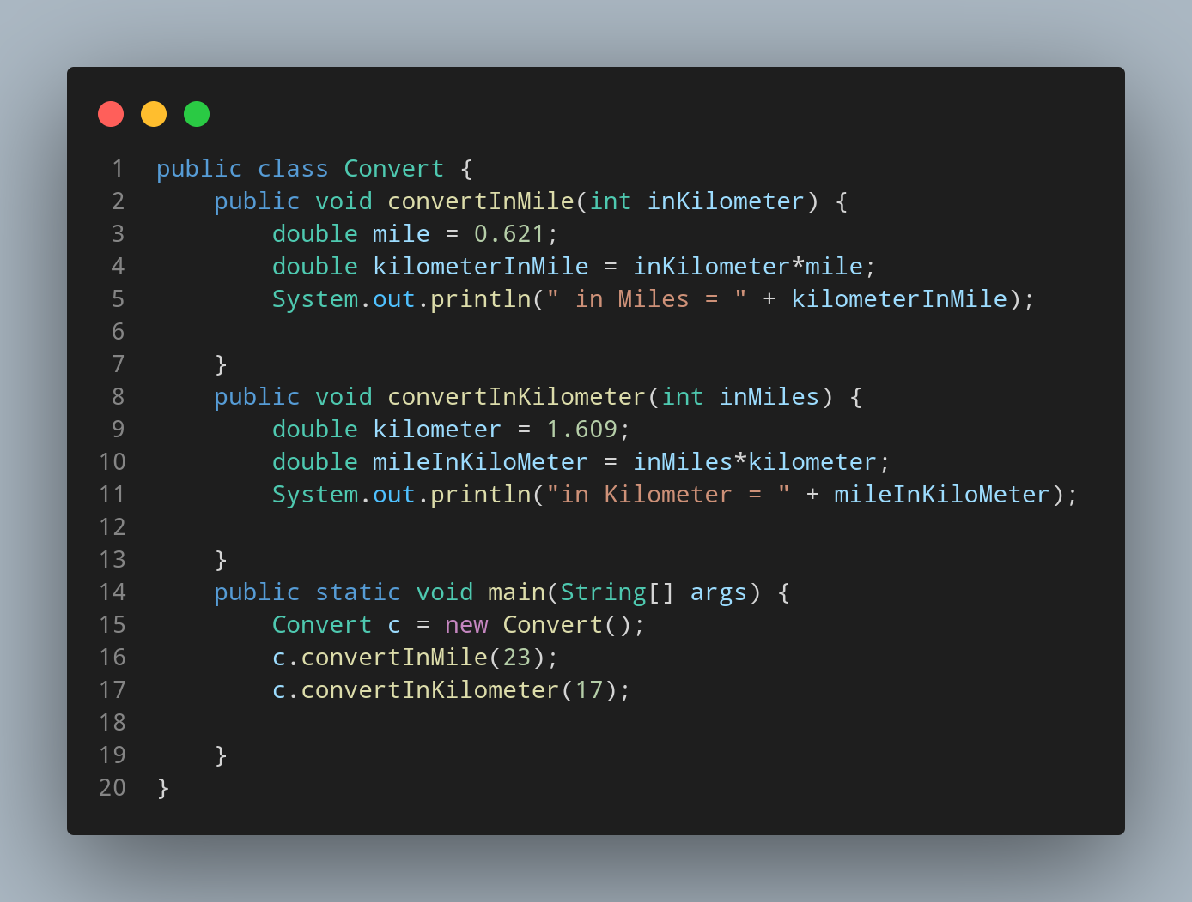

#Doc

We created our java file naming Convert so , we create a class having same name. Inside our class we created a method named convertInMile having int inKilometer as parameter. Then we created a variable to store the number of mile in one kilometer. Lets create a variable to store our Conversion calculated value named as kilometerInMile with leteral inKilometer*mile.

Then we print our variable with suitable strings.

Again we created a method named convertInKilometer having int inMiles as parameter. Then we created a variable to store the number of kilometer in one miles. Lets create a variable to store our Conversion calculated value named as mileInKilometer with leteral inMiles*kilometer.

Then we print our variable with suitable strings.

Now its time to create our main function.
Within main function first we instantiate our Convert class data type as variable c. Then we call our method giving the value of function parameter during calling method.

